MoodGPT: Creating Mood-boards for Music

Nicole Franco, Anna Huynh, Samantha Villafane

Dr. Jason Harrington

11 December 2023

MoodGPT: Creating Mood-boards for Music

**Introduction**

The goal of our project was to create an application called MoodGPT which would create mood-boards for user-selected songs based on their lyrics. The user would only have to input a song title and the artist for the program to feed their request through the Genius API and retrieve its lyrics. The lyrics were then selectively parsed into the Stability AI Image Generator, along with the phrase ‘3 squares by 3 squares grid mood-board of: ’, to produce a grid of images as a mood-board of the song. Finally, we created a Python GUI with Tkinter to facilitate easy user-interaction with the application. Aside from the packages and APIs mentioned, all work in this project was our own.

This project evolved minimally over time, but different variations had been discussed in the initial plans. For instance, we initially discussed using Spotify data to create related playlists based on listening patterns; this then morphed into using Genius data to create related playlists based on lyrics. The idea of mood-boards was introduced from this idea. We had also discussed creating slideshow or video presentations based on the images created by the generator, but ultimately did not go this route. Our final outcome of MoodGPT includes an interactive application that allows the user to enter a song and be presented with a lyrics-based mood-board, as well as a pie chart of the relative frequencies of the five most frequently repeated words in the song to get an idea of what words had the biggest influence on the image generation.

**Methods**

We created the module *genius_api.py* with the function *get_lyrics* to retrieve song lyrics for use in later programs. Genius is an online collection of song lyrics, often annotated by their respective artists, as well as music chart information, relevant news, music videos, and more. It is associated with Genius Developers and the Genius API, which can be used to directly peruse user-selected artist discographies and retrieve lyrics for user-selected songs (“LyricsGenius: a Python client”). To do so, we first created an API client to generate an API key, which gave us access to the database (“Getting Started”), then adjusted built-in parameters so that our outputs would not include labels and headings (“Usage”).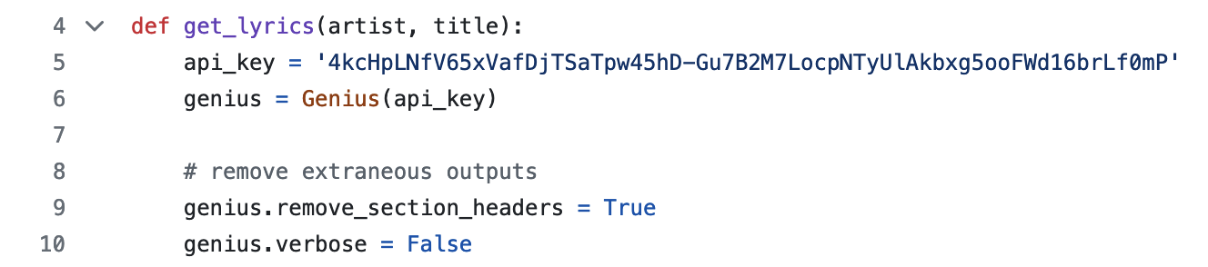

For a user-inputted artist and song title, *get_lyrics* uses the Genius API to search for the specified song and stores it in the variable *song*. The API is not case-sensitive and is able to handle small typographical errors, such as “tsylor swift” for “Taylor Swift”, and will more often than not be successful in searching for the desired song in such cases. As such, if a song is selected, the variable *song* is associated with the artist and title of the song Genius selects, not the input given by the user, to correct any typos and clarify if the desired song was found or not. The command *lyrics* is used to retrieve the song lyrics, which are then split by line into an array. Genius presents lyrics in separated sections, so we removed empty lines as elements equal to ‘’. The return values are the final array of lyrics and the artist and title from the song being presented, to replace the user input in later modules. This is useful in the case that the user input contains a typographical error or capitalization inconsistency; using the official artist names and song titles enhances the presentation of the final application.

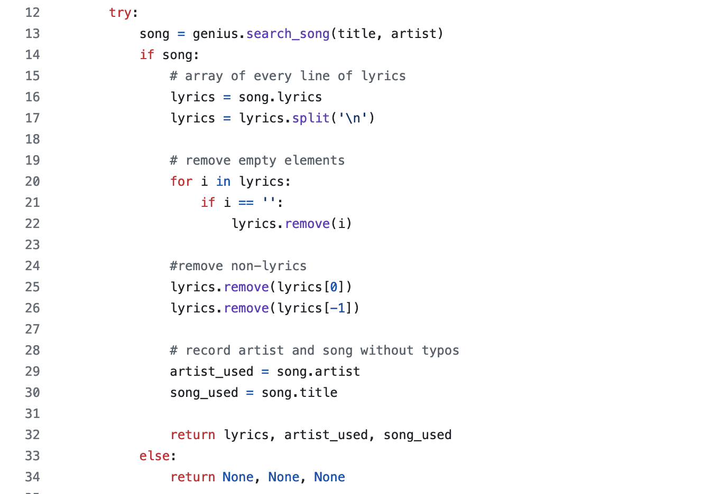

As shown above, if a song cannot be found, the program returns ‘None’ for all values so the final program may check for this possibility and produce an error message to the user (user8062171). Additionally, all of this is held within a try/except block so that the program will stop and alert the user in the event that the request times out.

With the lyrics retrieved, the *image_api.py* module is used to create the mood-board. This included multiple functions used to sort through the lyrics to extract the most significant words, feed them into the image generator, and report the most common titles. The first function, *create_sentence*, would accept a list of inputs to form a so-called sentence. The function *generate_title* uses spaCy as a Natural Language Processor (spaCy) to process each array of lyrics and extract entities and adjectives, hereafter referred to as “titles”.

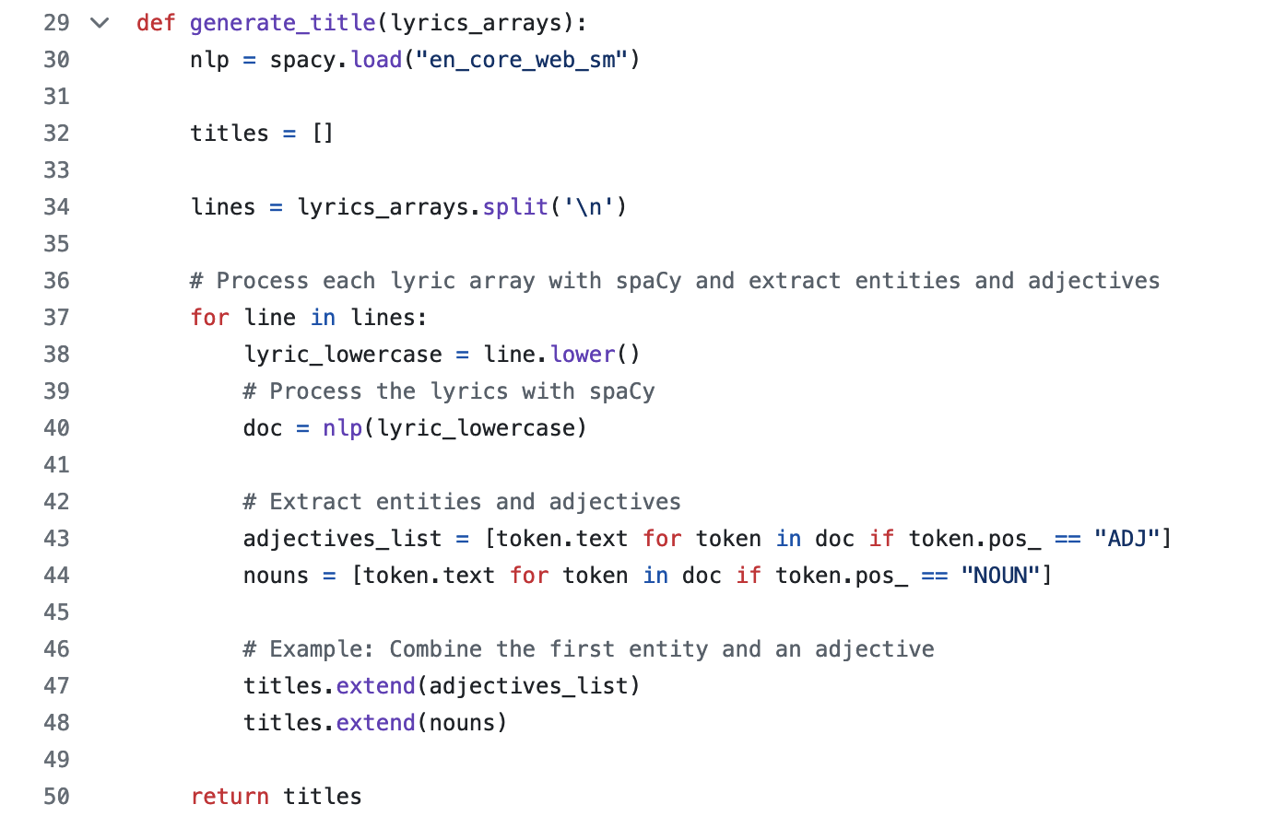

The primary purpose of this is to eliminate articles and prepositions, which were sure to be an overwhelming majority of the lyrics and would not provide any value to the image generator. Verbs are also notably excluded from this selection; our method rests on the assumption that most verbs would not provide significant contributions to the overall imagery of the songs.

Text is fed into the Stability AI with set size dimension and a negative prompt. A negative prompt basically states that this image does not include a certain thing. For this project, negative prompt was "blurriness" and "bad". The generator writes the PNG file as a file path. The file path then passes through the file reader function and saves it as a PNG file to display in the final result.

These functions are all used within the *execute* function, which accepts the array of song lyrics as an input and combines the previous functions to output a mood-board. The titles are combined into sentences, along with a short phrase to specify that the output should be a 3x3 grid, which is then fed into the image generator.

The final part of this module’s output was a report of the five most frequently repeated titles in the song. This was accomplished using a function called *top_5_words_and_counts*, which keeps count of each title, sorts them in descending order by frequency, and returns the top five with their respective counts. This mathematical computation was useful in collecting the titles used most frequently throughout the song, which helped us see which titles were fed into the image generator the most to produce the mood-board.

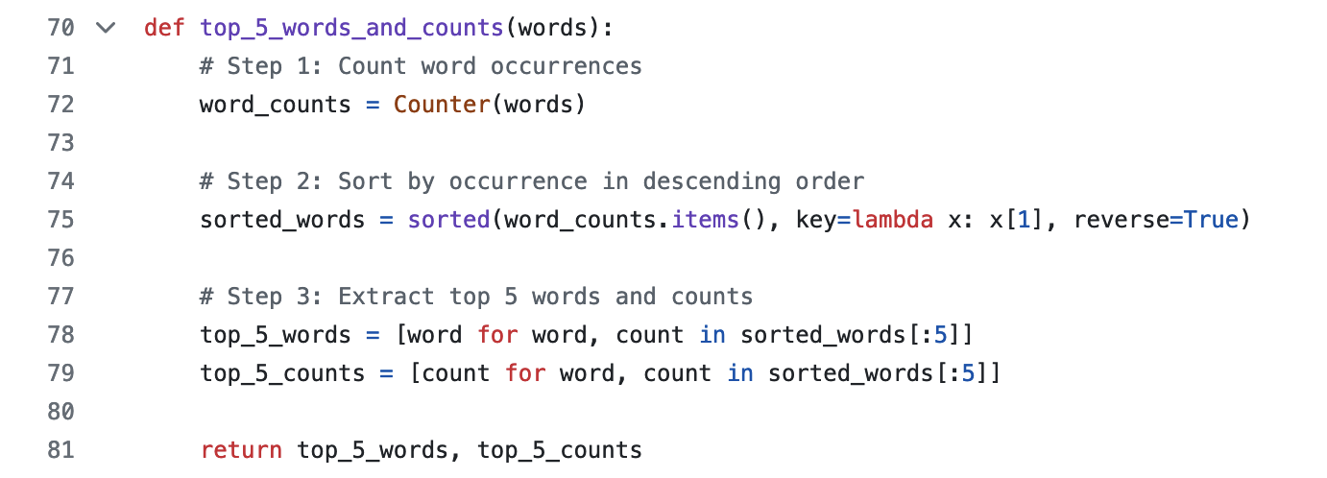

In the final module, *moodgpt_gui.py*, the outputs from the previous modules were combined and the application interface was created using Tkinter (Codemy.com). First, we created the background grid for the home page using AI generated images from Stability AI with the prompt of “generate an image that represents the vibe of the _ genre” for pop music, rap, rock, heavy metal, and more. Each of these images were resized to 250x250 pixels and positioned by pixel number. We created an exit button in the top right corner of the screen to allow the user to quit the program smoothly from the home page (Duhey).

The home screen also includes two user-input text boxes with prompts “Song Title: ” and “Artist Name: ” (user3033423). The user is instructed to delete these prompts in the README.md from these boxes and enter their desired song information.

We created a function called *open_window* which would open upon the user hitting the “Enter” button on the home screen. A message box with the text "Must delete text inside text box[es] before entering song title and artist name." will show in the case that the user did not delete the prompt text. If the information was entered successfully, the user input was fed into the *genius_api.py* program, and the artist name and song title were retrieved from the *song* variable from the Genius API song search. Another error window was created in the case that the song could not be found, as previously discussed. This window also appears if the user leaves the boxes blank.

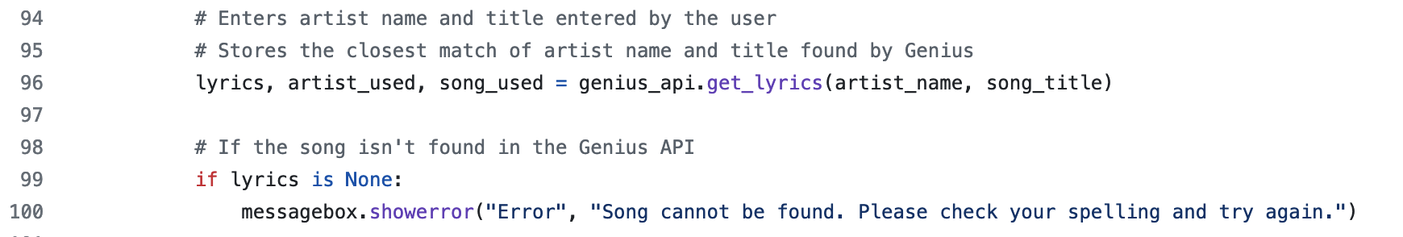

If the song exists, its lyrics are fed into the *execute* function from *image_api.py*, which returns the image. The Stability AI image generator may not generate an image if fed explicit or unsafe content, in which case another error window would open to report that the system detected potentially unsafe content. The program will use the *top_5_words_and_counts* function from *image_api.py* to hold the arrays of the most frequently repeated words and their frequencies.

We created another function called *display_data* for the final presentation of results. In a new window, we opened the mood-board file and positioned it side by side with the pie chart we created using matplotlib (Gromnitsky) to display the top five most common words and their relative frequencies, along with a legend of the words and their associated colors. We added a “Start Again” button underneath the pie chart so that the user could try more songs without having to rerun the program, as it takes a minute to load when running from scratch. The *reopen_root* function exits the mood-board window and reopens the home window.

**Results**

The user experience of the application is as follows. Upon opening the application, the user is greeted with the home screen, where the AI generated depictions of various music genres are displayed along with the text prompts. Here, the user can enter the song title and artist name. Clicking the “Enter” button begins the mood-board generation process.

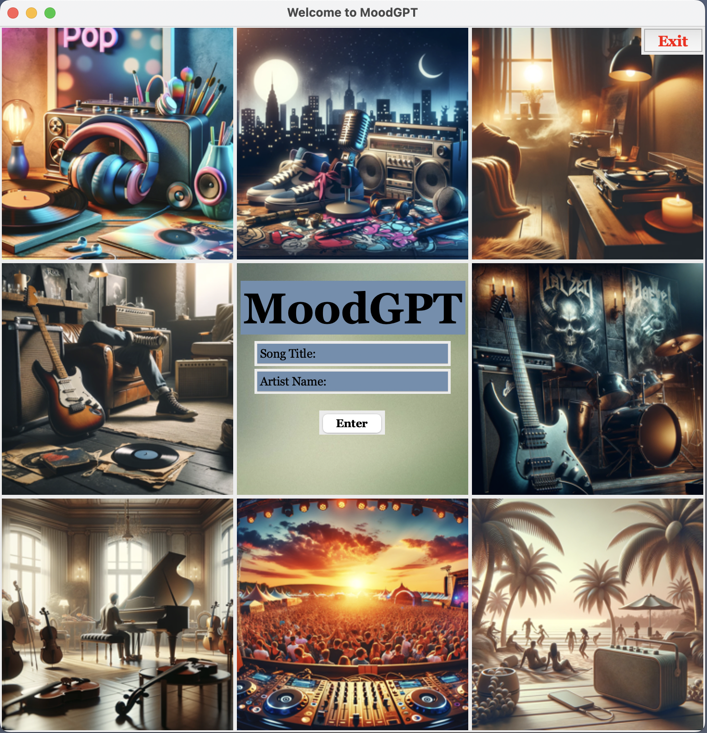

Examples are shown below of mood-boards for “Nobody” by Mitski and “Red” by Taylor Swift.

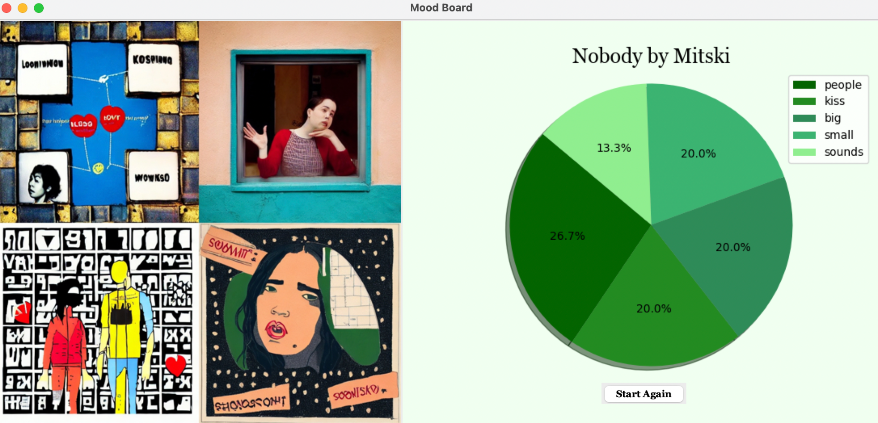

As extracted adjectives and nouns are from the original lyrics, we see how the amount of words affect the image. For example, when putting in some “Red” by Taylor Swift, one would expect more red tones throughout the image. But from seeing the top 5 mentioned extracted words, we can see why the image is covered in blues and grays given the lyrics. Our visualization of the top 5 most used words, show the weight it has on an image.

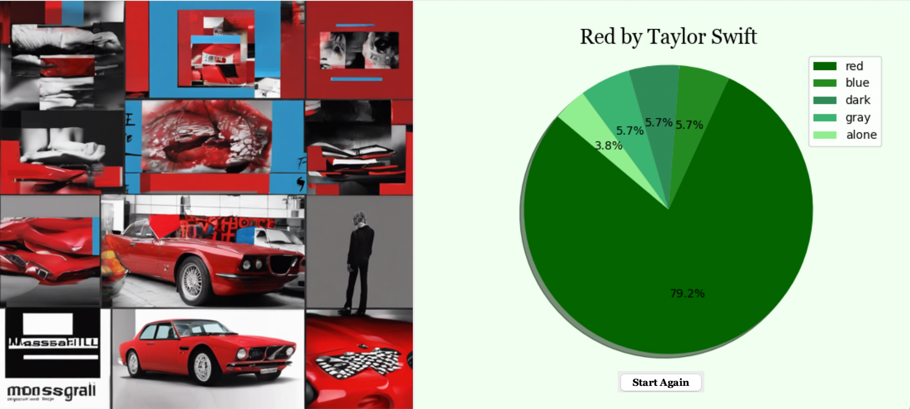

Still, despite our selectivity with the lyrics that we fed into Stability AI, some of the generated images were not particularly relevant to the lyrics or songs. We attributed this to faults of the Stability AI image generator; although we knew it was not a particularly strong generator, it was one of few that offered public access. We originally intended to use DALL-E, which is considered significantly better, but it does not offer public access, and the API key was disabled once we shared the code.

**Conclusions and Future Work**

In this project, we successfully created an application called MoodGPT, which accepts a user-selected song and uses the Genius API and DEEP AI image generator to create a mood-board for the song based on its lyrics. It can handle typographical errors and is prepared to report potential runtime failures associated with user input and the Genius API. MoodGPT can be used as visual inspiration for music videos or potential costuming.

Given more time, it might be helpful to consider different methods of selecting text to feed into the image generator. One particular method that comes to mind is potentially considering some verbs. For example, in Taylor Swift’s “Red”, she opens with, “Loving him is like trying to change your mind/ Once you’re already flying through the free fall.” The latter line could have been a significant contribution to the image generator had we selected the words “flying” and even “fall”, which may have been recognized—wrongly, in this context—as a verb. Using only adjectives and nouns heavily diminishes the imagery provided from these lines. However, later in “Red”, Swift sings, “Memorizing him was as easy as knowing all the words/ To your old favorite song.” The verbs in these lines (“memorizing”, “knowing”) are significantly less vivid. It would be beneficial to eliminate verbs such as these to avoid muddying the input fed to the image generator. This would require more detailed analysis that spaCy itself did not offer and resided far outside of our time constraints. Along those lines, it would also be beneficial to eliminate less useful titles as well. We could even determine different ways of using titles based on further categorization; for example, colors might be incorporated throughout all images to cast a hue over the entire mood-board.

One aspect of our original plan that we could not execute was our idea to present the final mood-board with the song playing in the background. We had initially hoped to use Spotify to do this, but found that even through the Spotify Web API, we were not able to play the song within our own application. Instead, once a song was specified, the API would open a browser to the song’s Spotify page. This was not ideal given that we wanted to create one cohesive application that could present the image and play audio on its own, without opening a browser as part of the output. Another option to play music was using Tkinter, but this required an already downloaded MP3 file. If we had chosen this option, our application would have been severely limited to pre-selected songs, and we wanted it to be useful for any song available in the Genius database. Given more time, we would have explored different avenues of playing music in the background of our final application. For example, Shazam and YouTube might offer ways to play songs without opening browsers or other applications, although options were not easy to find with cursory research. While this would not fix any issues with our current application, it would enhance the final presentation and user experience.

**Reflection**

To reflect on our project, researching the different APIs and documentation combined with GUI skills has only developed our curiosity. Prior to this project when we distributed our responsibilities, we had little to no experience within our given task. While it was a challenge to explore something new, it has opened a door for us to explore more APIs and enhanced our creativity when it comes to GUIs. While the three of us are not at all headed down a software route directly given our majors, it lets us explore something different that could later come in handy or at least give advice to people who need it as we now have experienced it firsthand. Ultimately, the new skills have given us a small taste of an expansive world when it comes to software.

**Sources**

Codemy.com. “Python’s GUI with TKinter.” YouTube, 1 Sept 2019,

<https://www.youtube.com/playlist?list=PLCC34OHNcOtoC6GglhF3ncJ5rLwQrLGnV>.

Dubey, Rahul. “Tkinter Icon.” *EDUCBA*, 23 Jun 2023, <https://www.educba.com/tkinter-icon/>.

“Getting Started.” *Genius*, <https://docs.genius.com/>.

Gromnitsky, Alexander. “List of all available matplotlib backends.” *Stack Overflow*, 23 Feb

2011, <https://stackoverflow.com/questions/5091993/list-of-all-available-matplotlib-backends>.

“Industrial-Strength Natural Language Processing in Python.” *spaCy*, <https://spacy.io/>.

“LyricsGenius: a Python client for the Genius.com API.” *LyricsGenius*,

<https://lyricsgenius.readthedocs.io/en/master/>.

“Usage.” *LyricsGenius*, <https://lyricsgenius.readthedocs.io/en/master/usage.html>.

user3033423. “How do you overlap widgets/frames in python tkinter?” *Stack Overflow*, 25 Nov

2013, <https://stackoverflow.com/questions/20199863/how-do-you-overlap-widgets-frames-in-python-tkinter>.

user9062171. “How to get a tkinter error message box [duplicate].” *Stack Overflow*, 6 Dec 2017,

<https://stackoverflow.com/questions/47676319/how-to-create-a-tkinter-error-message-box>.